Distributed File System

With the ever-growing technological expansion of the world, distributed systems are becoming more and more widespread. They are a vast and complex field of study in computer science. A distributed system in its most simplest definition is a group of computers working together to appear as a single computer to the end-user.

These machines have a shared state, operate concurrently and can fail independently without affecting the whole system’s uptime.

In this assignment, you will build a simple distributed file system that supports reading and writing mp4 files while keeping files replicated for fault tolerance.

# Architecture

DFS is a centralized distributed system having 2 types of machine nodes. First, the **Master Tracker** node. This node has a look-up table. The look-up table columns are *(file name, Data Keeper node, file path on that data node, is data node alive)*. Second, the **Data Keeper** nodes which are the actual nodes that have the data files. Both the **Master Tracker** and **Data Keeper** nodes should be multi-threaded to handle multiple requests simultaneously. (Check <https://go.dev/tour/concurrency/11> for more about concurrency in Go)

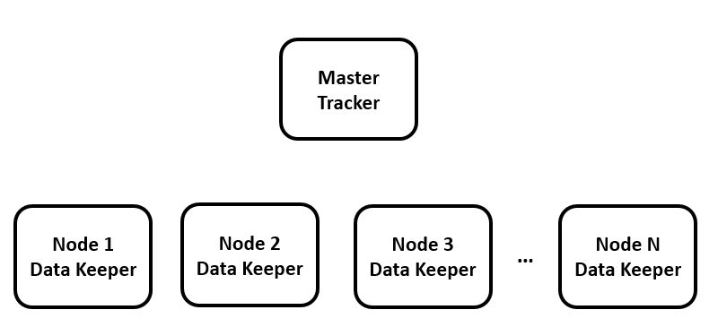

## Communication

All communication between **Master Tracker, Data Keepers** and **Clients** should be over gRPC. File transfers should be over tcp.

## Heartbeats

Every 1 sec, each data keeper node sends a keepalive ping to the master tracker node. The master tracker node then updates the look-up table mentioned above. If one of the data keeper nodes is down it will change the corresponding cell in the ’is data node alive’ column.

## Uploading A file

For a client to upload a file to a cluster, the following protocol MUST be followed:

1. A client process MUST communicate with the master tracker node.
2. The master tracker responds with a port number of one of the data keeper nodes.
3. The client then constructs a communication with this port, and transfers the file to it.
4. When the transferring procedure is finished, the data keeper node will then notify the master tracker.
5. The master tracker then adds the file record to the main look-up table.
6. The master will notify the client with a successful message.
7. The master chooses 2 other nodes to replicate the file transferred.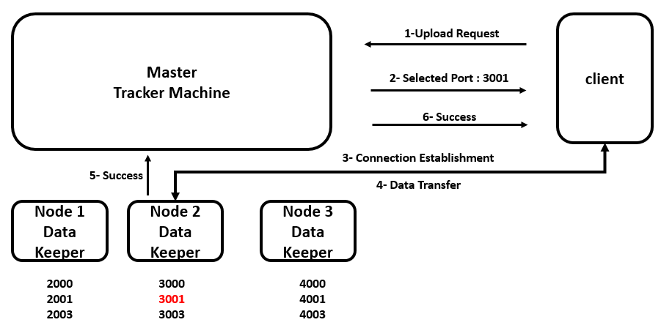

## 

## Replication

A separate thread on the **Master Tracker** should awake every *(n= 10)* seconds and check for replication according to the below algorithm. Each file should exist on at least 3 alive data nodes.

initialization;

**for** k: distinct file instances **do**

source_machine = getSourceMachine(file[k]);

**while** getInstanceCount(file[k]) is less than 3 **then**

destination_machine = selectMachineToCopyTo();

notifyMachineDataTransfer(source_machine, destination_machine, file[k]);

**end**

**end**

**getSourceMachine** is a function that takes a file record, then gets the source machine and the file path on that machine.

**selectMachineToCopyTo** returns a valid IP and a valid port of a machine to copy a file instance to.

**notifyMachineDataTransfer** This function must notify both source and destination machine to start copying the file.

## Downloading A file

A client can download his mp4 files. The following protocol MUST be followed:

1. Client request from the Master Tracker to download a certain file name.
2. Master Tracker responds with a list of machines IPs and ports to download a file from.
3. Client MUST request from every port **uniformly**. (Parallel download is considered a bonus)

# Rules

* You are required to build the **Master Tracker, Data Keeper and Client.**
* Team consists of up to 4 members.
* Submission **Due 11:59 PM, Saturday 16/03/2024** on <https://forms.gle/SM5dZP4SEBR9i2fn9>
* Discussion will be on Sunday 17 Mar. during tutorial time.
* Plagiarism will result in zero grade.